Project Report

Industrial Training

M Code: 78336

DAV Institute of Engineering & Technology, Jalandhar

Department of Computer Science & Engineering

Submitted By:

Anmolpreet Singh

Univ. Roll No. - 1803651

Devesh

Univ. Roll No. – 1803661

**Certificate**

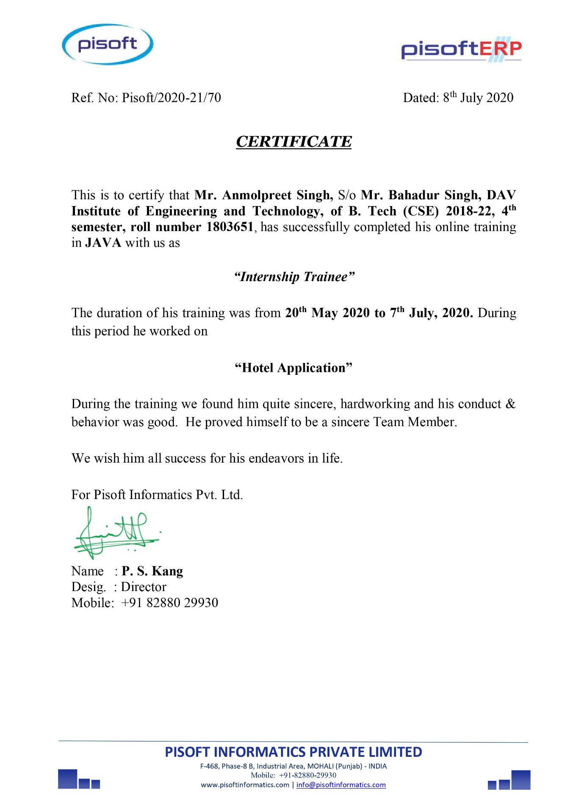

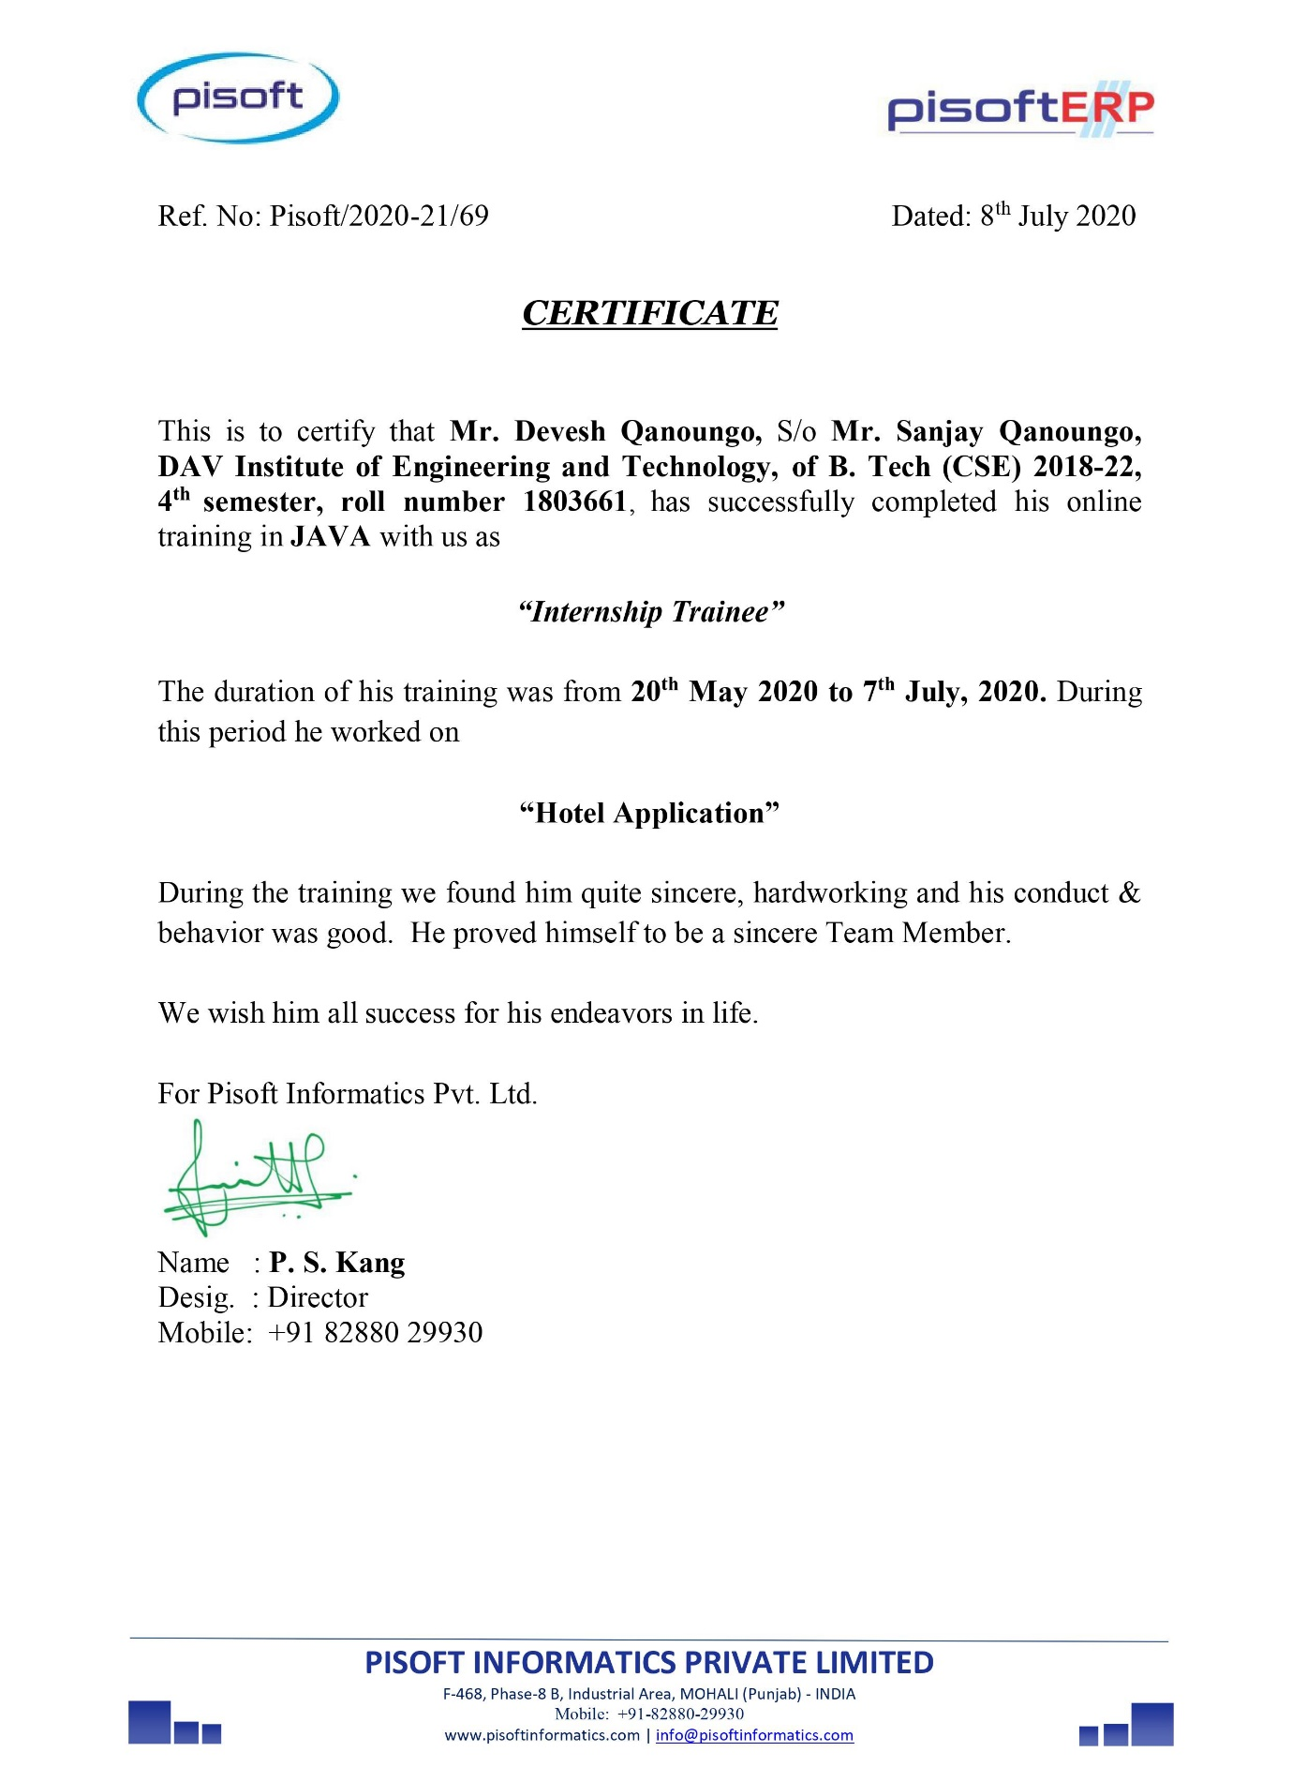

**Acknowledgement**

Presentation, Inspiration and Motivation have always played a key role in the success of any venture.

We pay our deep sense of gratitude to Dr. Harpreet Bajaj, Head of Department of Computer Science, DAV Institute of Engineering and Technology, Jalandhar to encourage us to the highest peak and to provide us the opportunity to prepare the project. We are immensely obliged to my friends for their elevating inspiration, encouraging guidance and kind supervision in the completion of our project.

At last, we like to express our sincere heartfelt gratitude to all the staff members of the Computer Science Department who helped us directly or indirectly during this course of work.

Anmolpreet Singh

Devesh

**ABSTRACT**

This application is specially developed to help hotel staff. The project Hotel Management manages and maintains the records of customers and room in the hotel.

The rooms have different categories such as Single Bed and Double Bed, So their charges and records will be maintained accordingly.

This software has been made in a user-friendly interface, so that anyone can add, delete the entries of customers and handle all the transactions easily. As a security we have provided Admin level authentication for different modules also the user name and password get stored in the database in encrypted format more dealing with the security.

Customer can directly Check-In. For the convenience of Administration, we have provided facility to generate report of transactions made in terms of check-in & check-out.

We have also provided the facility of pick-up service for the convenience of the customer.

Admin is also provided with the rights to add employees and drivers.

The result of the application was as desired. The application scaled all the different platforms, and all the required requirements were fulfilled.

**Contents**

1. Introduction 1
   1. Desktop Development 1
2. Technologies Learned 1
   1. Overview 1
      1. Core Java 1
      2. Java Swing 4
      3. MySQL 6
      4. JDBC 8
   2. Demonstration of Project 9
      1. Software/Platforms 9
         1. MySQL (SQLyog Enterprise) 9
         2. Eclipse IDE 11
   3. Assignments/Projects 24
      1. Number Guessing Game 24
      2. Digital Clock 26
3. Conclusion and Future work 28
   1. Conclusion 28
   2. Future Work 28

1. **Introduction** 
   1. Desktop Application

Desktop Applications are run stand alone on the user’s laptops and systems. The term used for these applications’ desktop differ these apps from mobile applications which is in the trend. The key features of desktop applications are the efficiency of the application is high and also these are highly customized as per user’s requirements and flexibility.

The applications installed on the system’s local server known as the desktop apps, you can install it from the online websites or use the CD drive to complete the installation process. After the installation process, it does not require any internet connection to access, it works on the system’s local server.

Sometimes, it looks people do not contrast between desktop or web applications, although they are different from each other. The primary difference of both are desktop apps runs on the local server of the computer devices and web applications work over the internet remote access.

1. **TECHNOLOGIES LEARNED:**
   1. Overview
      1. Core Java

**What is Java?**

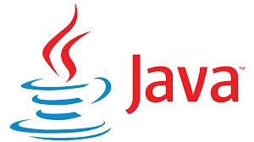

Java is a programming language and a platform. Java is a high level, robust, object-oriented and secure programming language.

Java was developed by Sun Microsystems (which is now the subsidiary of Oracle) in the year 1995. James Gosling is known as the father of Java. Before

Java, its name was Oak. Since Oak was already a registered company, so James Gosling and his team changed the Oak name to Java.

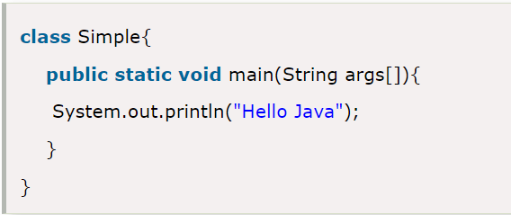**Example:**

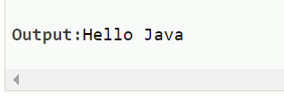

**Features of JAVA**

A list of most important features of Java language is given below:

* 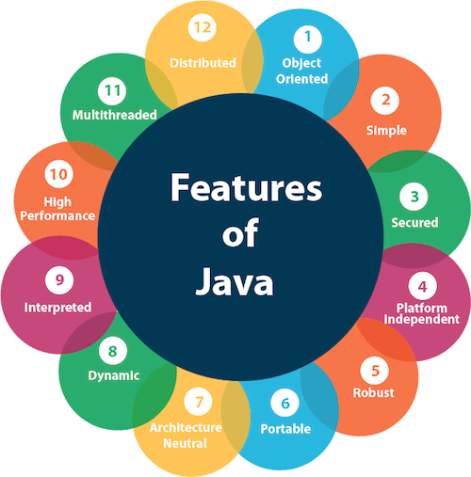Simple
* Object-Oriented
* Portable
* Platform independent
* Secured
* Robust
* Architecture neutral
* Interpreted
* High Performance
* Multithreaded
* Distributed
* Dynamic

**JVM**

JVM (Java Virtual Machine) is an abstract machine. It is called a virtual machine because it doesn't physically exist. It is a specification that provides a runtime environment in which Java bytecode can be executed. It can also run those programs which are written in other languages and compiled to Java bytecode.

JVMs are available for many hardware and software platforms. JVM, JRE, and JDK are platform dependent because the configuration of each [OS](https://www.javatpoint.com/os-tutorial) is different from each other. However, Java is platform independent. There are three notions of the JVM: specification, implementation, and instance.

The JVM performs the following main tasks:

* Loads code
* Verifies code
* Executes code
* Provides runtime environment

**JRE**

JRE is an acronym for Java Runtime Environment. It is also written as Java RTE. The Java Runtime Environment is a set of software tools which are used for developing Java applications. It is used to provide the runtime environment. It is the implementation of JVM. It physically exists. It contains a set of libraries + other files that JVM uses at runtime.

**JDK**

JDK is an acronym for Java Development Kit. The Java Development Kit (JDK) is a software development environment which is used to develop Java applications and [applets](https://www.javatpoint.com/java-applet). It physically exists. It contains JRE + development tools.

JDK is an implementation of any one of the below given Java Platforms released by Oracle Corporation:

* Standard Edition Java Platform
* Enterprise Edition Java Platform
* Micro Edition Java Platform

The JDK contains a private Java Virtual Machine (JVM) and a few other resources such as an interpreter/loader (java), a compiler (javac), an archiver (jar), a documentation generator (Javadoc), etc. to complete the development of a Java Application.

* + 1. Java Swing

Java Swing tutorial is a part of Java Foundation Classes (JFC) that is used to create window-based applications. It is built on the top of AWT (Abstract Windowing Toolkit) API and entirely written in java.

Unlike AWT, Java Swing provides platform-independent and lightweight components. The javax.swing package provides classes for java swing API such as JButton, JTextField, JTextArea, JRadioButton, JCheckbox, JMenu, JColorChooser etc.

**Hierarchy of Java Swing classes**

The hierarchy of java swing API is given below.

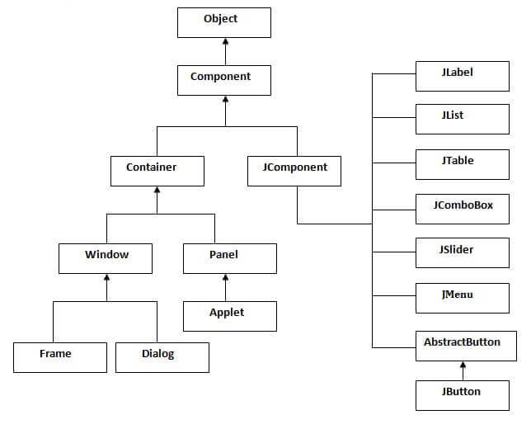

**Example:**

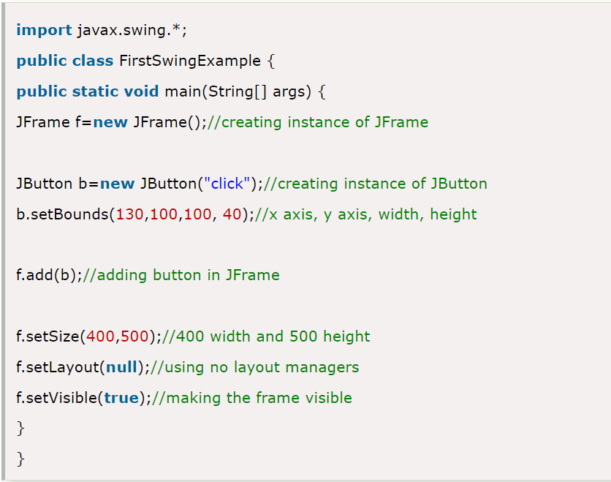

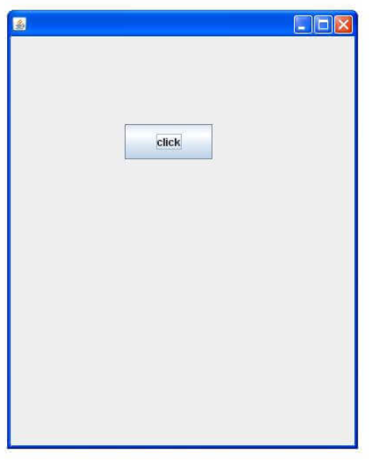

* + 1. MySQL

**What is Database?**

A database is an application that stores the organized collection of records. It can be accessed and manage by the user very easily. It allows us to organize data into tables, rows, columns, and indexes to find the relevant information very quickly. Each database contains distinct [API](https://www.javatpoint.com/api-full-form) for performing database operations such as creating, managing, accessing, and searching the data it stores. Today, many databases available like MySQL, Sybase, [Oracle](https://www.javatpoint.com/what-is-oracle), [MongoDB](https://www.javatpoint.com/mongodb-tutorial), [PostgreSQL](https://www.javatpoint.com/postgresql-tutorial), [SQL Server](https://www.javatpoint.com/sql-server-tutorial), etc.

**What is MySQL?**

MySQL is currently the most popular database management system software used for managing the relational database. It is open-source database software, which is supported by Oracle Company. It is fast, scalable, and easy to use database management system in comparison with Microsoft SQL Server and Oracle Database.

It is developed, marketed, and supported by **MySQL AB, a Swedish company,** and written in [C programming language](https://www.javatpoint.com/c-programming-language-tutorial) and [C++ programming language](https://www.javatpoint.com/cpp-tutorial). The official pronunciation of MySQL is not the My Sequel; it is **My Ess Que Ell.** Many small and big companies use MySQL. MySQL supports many Operating Systems like [Windows](https://www.javatpoint.com/windows), [Linux](https://www.javatpoint.com/linux-tutorial), MacOS, etc. with C, C++, and [Java languages](https://www.javatpoint.com/java-tutorial).

MySQL is a [Relational Database Management System](https://www.javatpoint.com/what-is-rdbms) (RDBMS) software that provides many things, which are as follows:

* It allows us to implement database operations on tables, rows, columns, and indexes.
* It defines the database relationship in the form of tables (collection of rows and columns), also known as relations.
* It provides the Referential Integrity between rows or columns of various tables.
* It allows us to updates the table indexes automatically.
* It uses many SQL queries and combines useful information from multiple tables for the end-users.

**How MySQL Works?**

MySQL follows the working of Client-Server Architecture. This model is designed for the end-users called clients to access the resources from a central computer known as a server using network services. Here, the clients make requests through a graphical user interface (GUI), and the server will give the desired output as soon as the instructions are matched. The process of MySQL environment is the same as the client-server model.

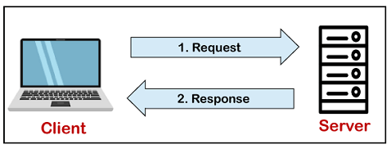

The core of the MySQL database is the MySQL Server. This server is available as a separate program and responsible for handling all the database instructions, statements, or commands. The working of MySQL database with MySQL Server are as follows:

1. MySQL creates a database that allows you to build many tables to store and manipulate data and defining the relationship between each table.
2. Clients make requests through the GUI screen or command prompt by using specific SQL expressions on MySQL.
3. Finally, the server application will respond with the requested expressions and produce the desired result on the client-side.

A client can use any MySQL [GUI](https://www.javatpoint.com/gui-full-form). But it is making sure that your GUI should be lighter and user-friendly to make your data management activities faster and easier. Some of the most widely used MySQL GUIs are MySQL Workbench, SequelPro, DBVisualizer, and the Navicat DB Admin Tool. Some GUIs are commercial, while some are free with limited functionality, and some are only compatible with MacOS. Thus, you can choose the GUI according to your needs.

* + 1. JDBC

JDBC stands for Java Database Connectivity. JDBC is a Java API to connect and execute the query with the database. It is a part of JavaSE (Java Standard Edition). JDBC API uses JDBC drivers to connect with the database. There are four types of JDBC drivers:

* JDBC-ODBC Bridge Driver,
* Native Driver,
* Network Protocol Driver, and
* Thin Driver

We can use JDBC API to access tabular data stored in any relational database. By the help of JDBC API, we can save, update, delete and fetch data from the database. It is like Open Database Connectivity (ODBC) provided by Microsoft.

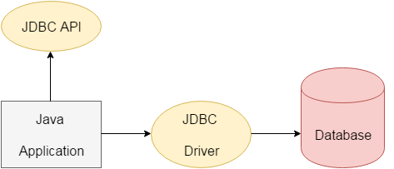

The current version of JDBC is 4.3. It is the stable release since 21st September, 2017. It is based on the X/Open SQL Call Level Interface. The java.sql package contains classes and interfaces for JDBC API. A list of popular interfaces of JDBC API are given below:

* Driver interface
* Connection interface
* Statement interface
* PreparedStatement interface
* CallableStatement interface
* ResultSet interface
* ResultSetMetaData interface
* DatabaseMetaData interface
* RowSet interface

A list of popular classes of JDBC API are given below:

* DriverManager class
* Blob class
* Clob class
* Types class

**Why Should We Use JDBC**

Before JDBC, ODBC API was the database API to connect and execute the query with the database. But, ODBC API uses ODBC driver which is written in C language (i.e. platform dependent and unsecured). That is why Java has defined its own API (JDBC API) that uses JDBC drivers (written in Java language).

We can use JDBC API to handle database using Java program and can perform the following activities:

1. Connect to the database
2. Execute queries and update statements to the database
3. Retrieve the result received from the database.
4. DEMONSTRATION OF PROJECT
5. Software/Platforms
6. MySQL (SQLyog Enterprise)



SQLyog is a [GUI](https://en.wikipedia.org/wiki/Graphical_user_interface) tool for the [RDBMS](https://en.wikipedia.org/wiki/RDBMS) [MySQL](https://en.wikipedia.org/wiki/MySQL). It is developed by Webyog, Inc., based in [Bangalore, India](https://en.wikipedia.org/wiki/Bangalore,_India), and [Santa Clara, California](https://en.wikipedia.org/wiki/Santa_Clara,_California). SQLyog is being used by more than 30,000 customers worldwide and has been downloaded more than 2,000,000 times.

**History**

SQLyog v0.9 was first released to the public in 2001 after eight months of development. SQLyog was available free of charge, but with closed source code, until v3.0 when it was made a fully commercial software. Nowadays SQLyog is distributed both as [free software](https://en.wikipedia.org/wiki/Free_software) as well as several paid, proprietary, versions. The free software version is known as Community Editio at [GitHub](https://en.wikipedia.org/wiki/GitHub). Paid versions are sold as Professional, Enterprise and Ultimate Editions.

Starting window of SQLyog

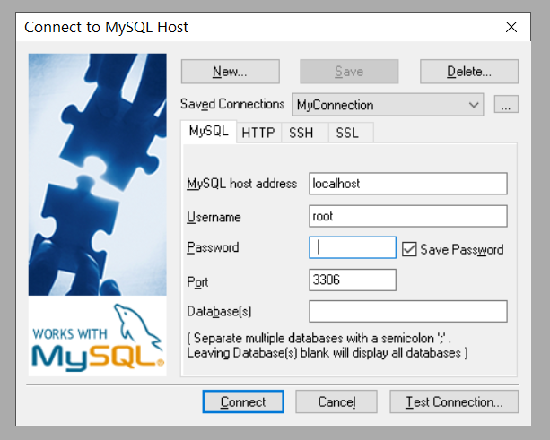

**Database Tables used in our project:**

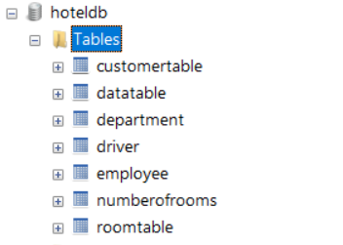

1. Eclipse IDE



Eclipse is an integrated development environment (IDE) for developing applications using the Java programming language and other programming languages such as C/C++, Python, PERL, Ruby etc.

The Eclipse platform which provides the foundation for the Eclipse IDE is composed of plug-ins and is designed to be extensible using additional plug-ins. Developed using Java, the Eclipse platform can be used to develop rich client applications, integrated development environments and other tools. Eclipse can be used as an IDE for any programming language for which a plug-in is available.

The Java Development Tools (JDT) project provides a plug-in that allows Eclipse to be used as a Java IDE, PyDev is a plugin that allows Eclipse to be used as a Python IDE, C/C++ Development Tools (CDT) is a plug-in that allows Eclipse to be used for developing application using C/C++, the Eclipse Scala plug-in allows Eclipse to be used an IDE to develop Scala applications and PHPeclipse is a plug-in to eclipse that provides complete development tool for PHP.

**Reference Libraries used**

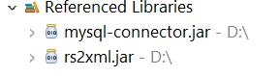

**WindowBuilder**

WindowBuilder is composed of SWT Designer and Swing Designer and makes it very easy to create Java GUI applications without spending a lot of time writing code. Easily add controls using drag-and-drop, add event handlers to your controls, change various properties of controls using a property editor, internationalize your app and much more.

WindowBuilder is built as a plug-in to Eclipse and the various Eclipse-based IDEs.

Generated code doesn't require any additional custom libraries to compile and run: all of the generated code can be used without having WindowBuilder Pro installed. WindowBuilder Pro can read and write almost any format and reverse-engineer most hand-written Java GUI code. It also supports free-form code editing (make changes anywhere...not just in special areas) and most user re-factorings (you can move, rename and subdivide methods without a problem).

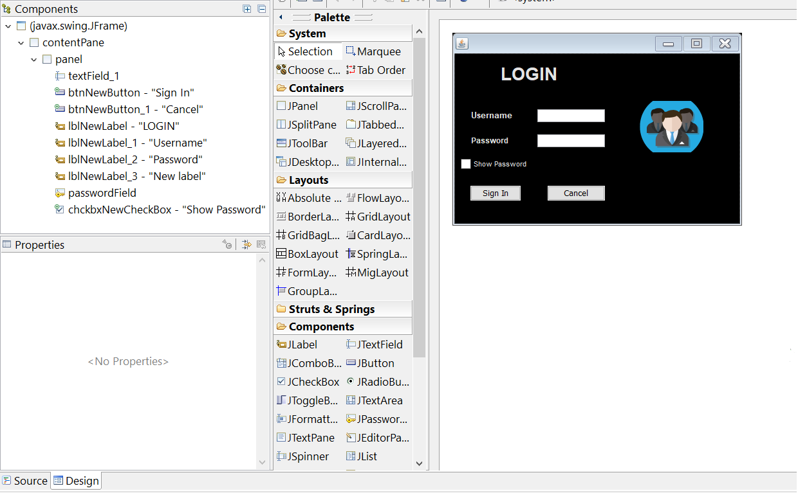

**Screenshots:**

1. 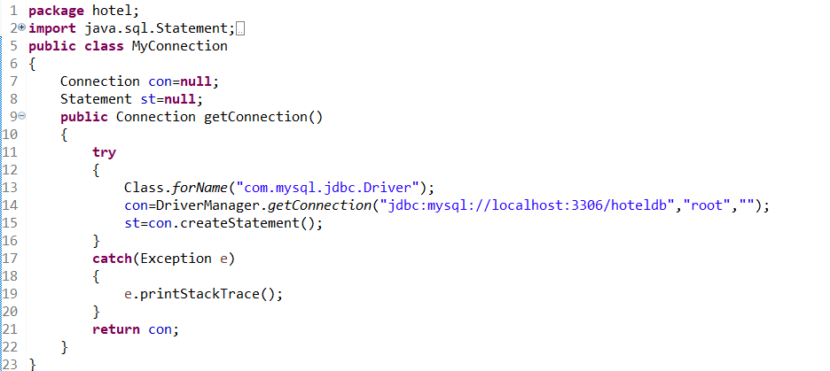**Code snippet of setting up connection with backend**
2. **Login page-** This is the first page of our project in which you enter username and password to sign in. After signing in you will be directed to dashboard.

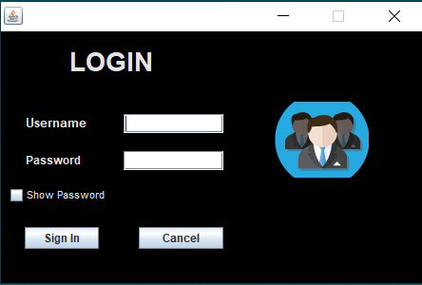

1. **Dashboard-** This is the Dashboard in which we are provided with 2 options
   1. Hotel Management- This option redirects us to reception.
   2. Admin- This option provides us to add rooms, drivers,and employees.

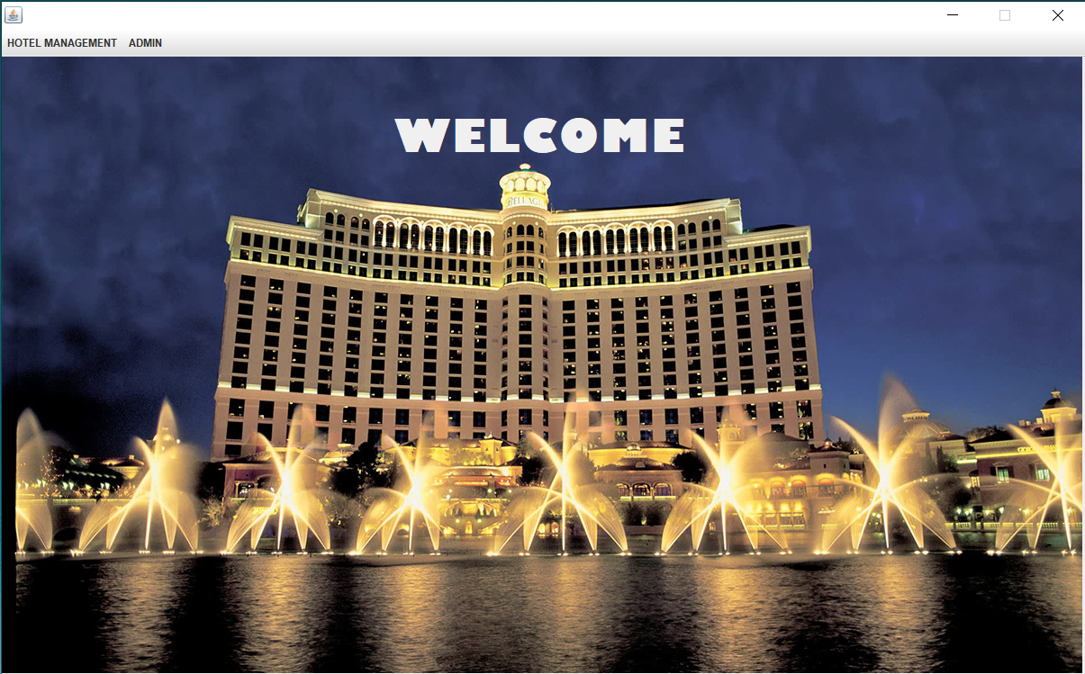

1. **Reception-** This page provides with many options such as to add new customer, to check the room details, to check employee info, customer info, to update room and check status, to search the availability of room, to check out etc.

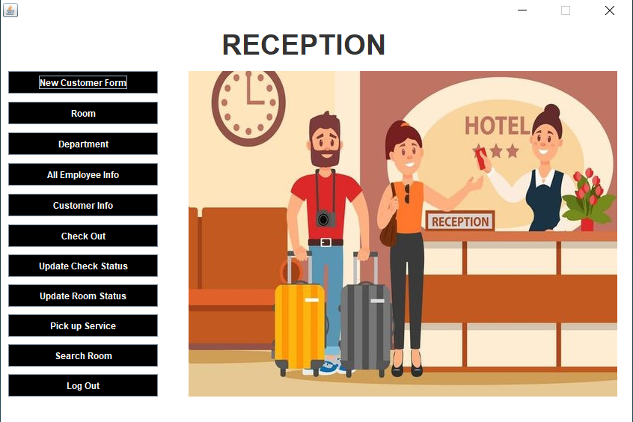

1. **Add employee-** This page allows admin to enter the details of new employee. This page takes the name, age, gender, salary, phone number, email, and job of the employee.

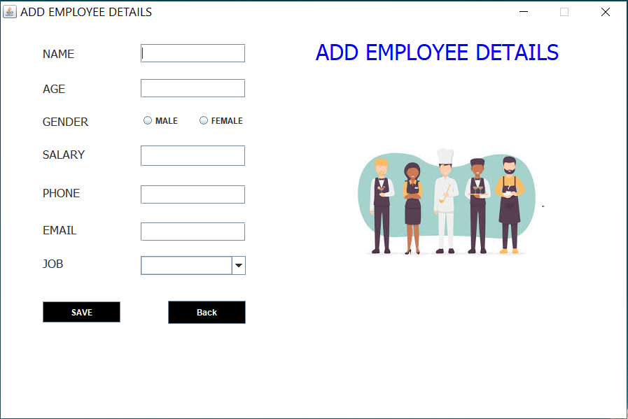

1. 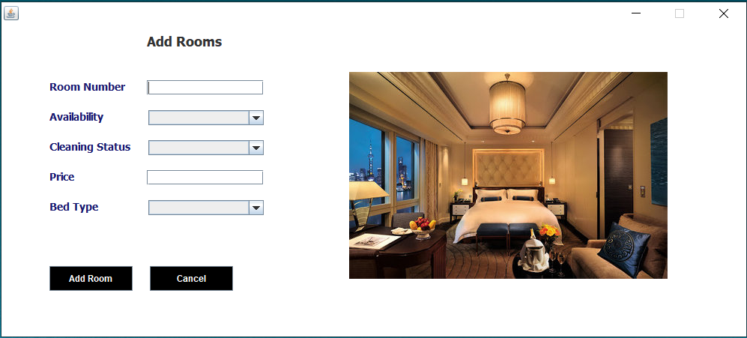**Add Room-** In this page we can add a new room. It takes the following field room number, avaliability, cleaning status, price and bed type.
2. **Add Drivers-** This page takes the following details name, age, gender,car company and brand, location and availability and add these details to the driver table.

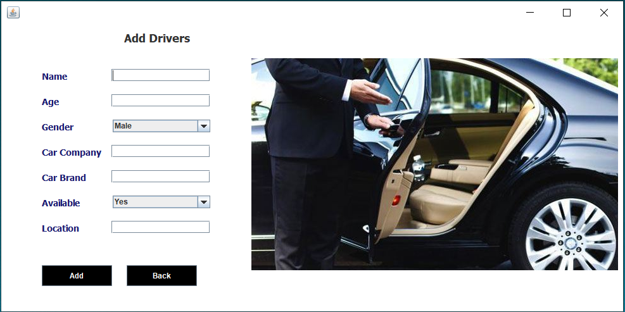

1. **New Customer Form-** This page allows to add a new customer which takes the following details such as ID, ID number, name, gender, country, allocated room number, check in date, deposit and saves these details in the backend.

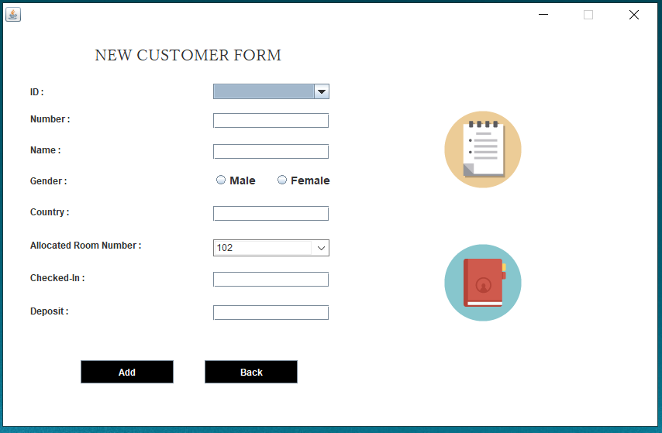

1. 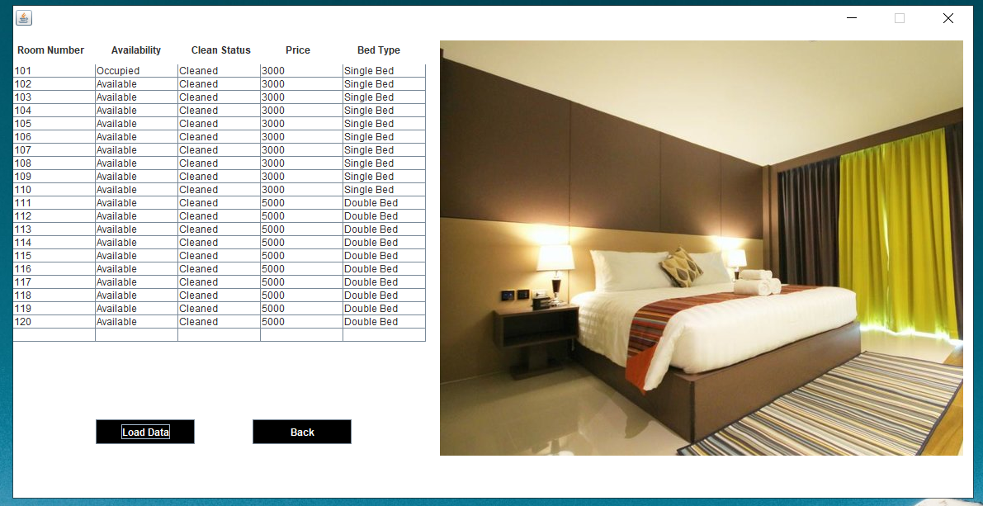**Room-** This page displays the details of the rooms such as room number, availability, clean status, price, bed type.
2. **Department-** This page shows us the budget of different departments in hotel.

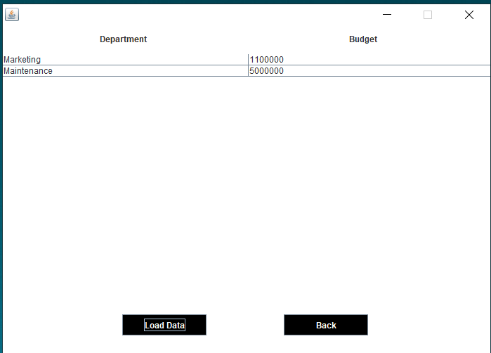

1. **Employee Info-** This page displays the information of all the employees in the hotel such as Employee Id, name, age, gender, job, salary, phone, email.

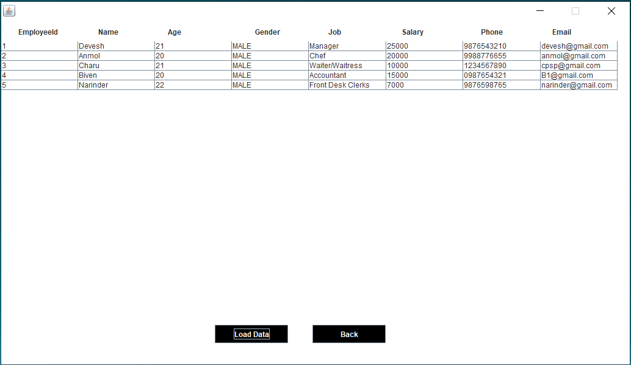

1. **Customer Info-** It displays information of all the customers staying in the hotel.

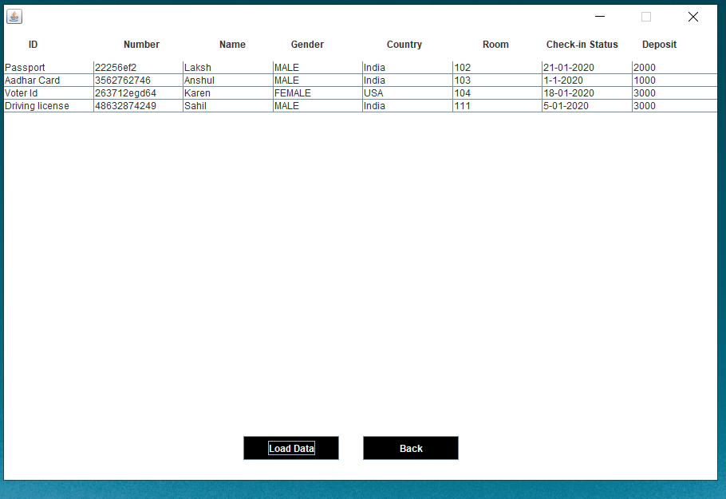

1. 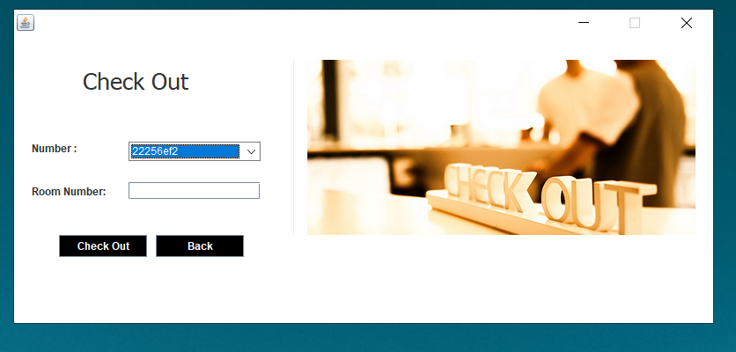 **Check Out-** This page checks out the customer and the customer entry is removed from the back end.
2. 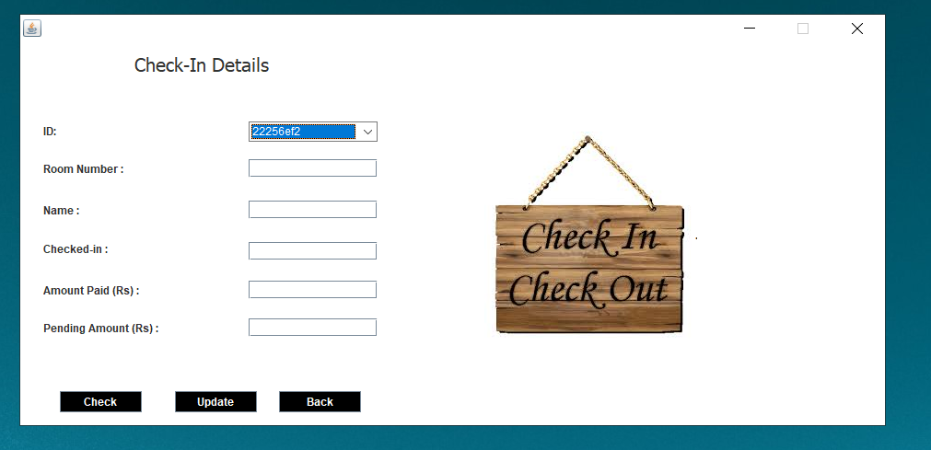 **Update Check Status-** This page is used to check details of the customer which has been successfully registered and the details of customer can also be updated from this page.
3. 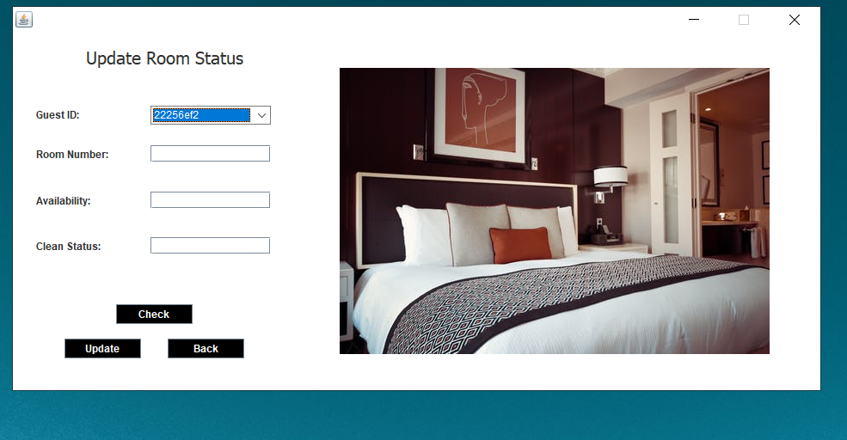 **Update Room Status-** This page allows to check the room status of the particular guest and the status can also be updated.
4. 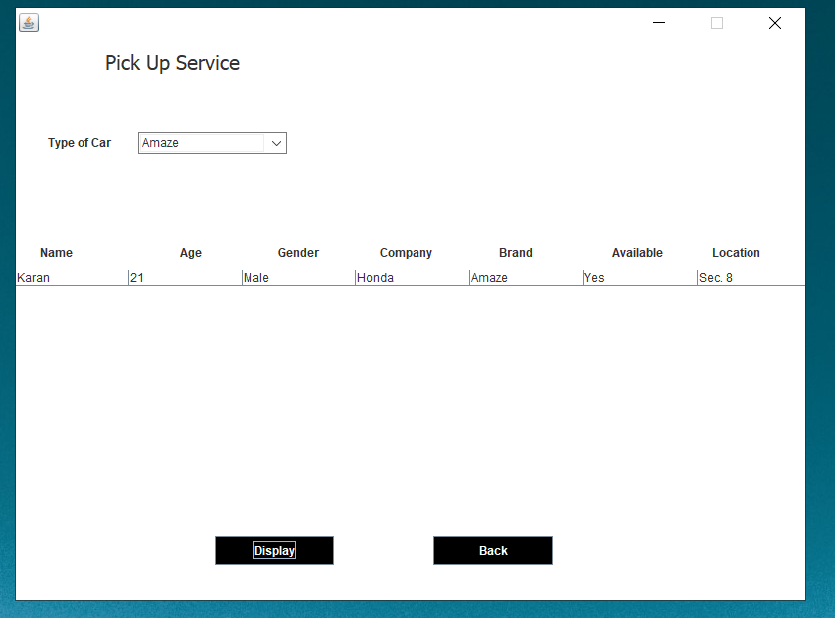 **Pick Up Service-** This window displays the details of drivers available with their location and their car brand, company, gender, age and name.
5. 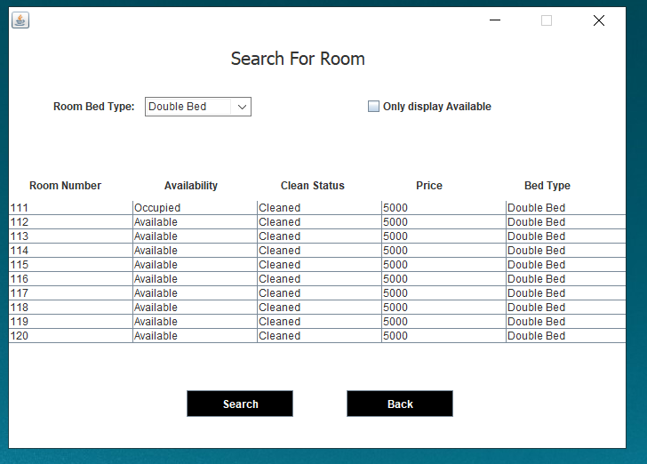 **Search Room-** This page helps to search for the rooms available in the hotel and the details of room such as room number, availability, clean status, price, bed type.
6. Assignments/Projects
7. Number Guessing Game

The fun and easy project “Guess the Number” is a short Java project that allows the user to guess the number generated by the computer & involves the following steps:

1. The system generates a random number from a given range, say 1 to 100.
2. The user is prompted to enter their given number in a displayed dialogue box.
3. The computer then tells if the entered number matches the guesses number or it is higher/lower than the generated number.
4. The game continues under the user guessing the number.

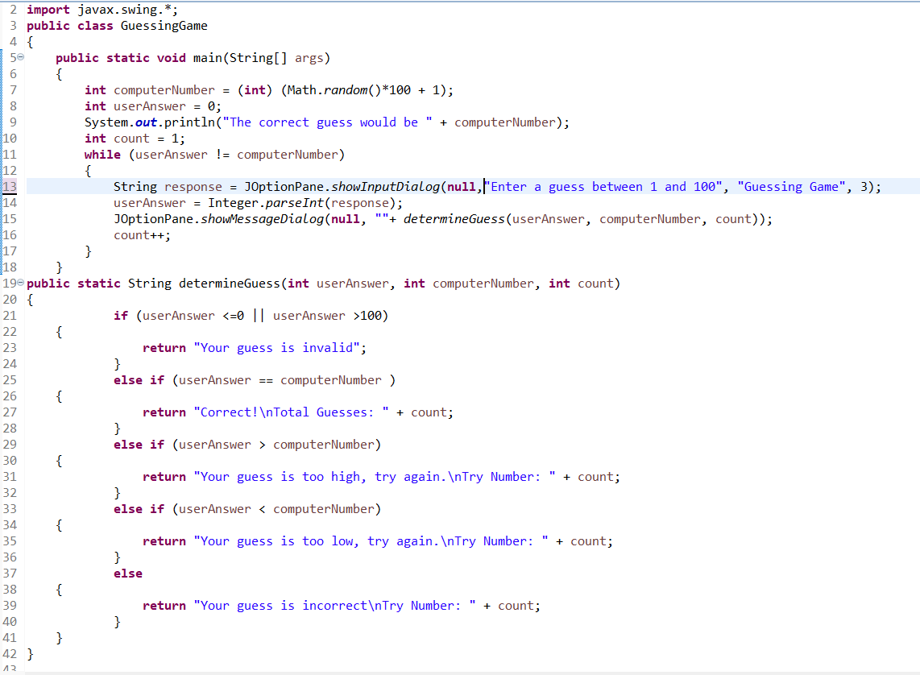**Source code**

**Screenshots**

**Starting Window**

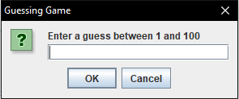

**If number is high**

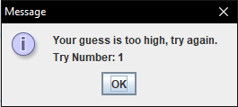

**If number is low**

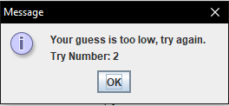

**When guessed right**

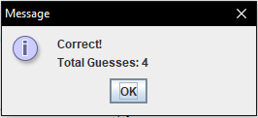

1. Digital Clock

To make a digital clock we need to use the Thread and Graphics classes of Java. Threads are used to change the seconds, minutes, and hours of the clock and the Graphics class is used for the design of the clock.

**Source code**

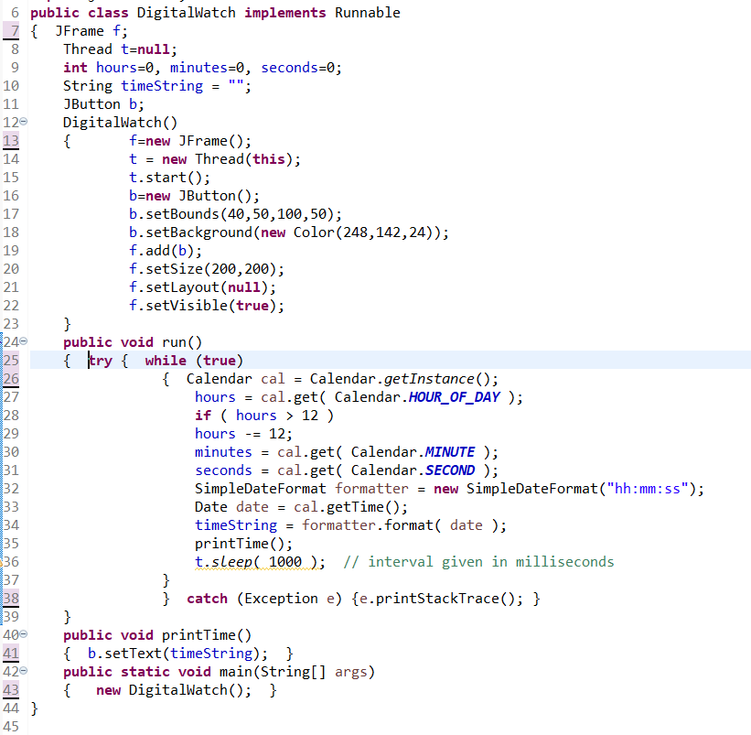

**Screenshot**

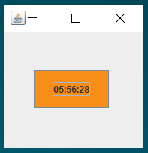

1. **Conclusion and Future Work**
2. Conclusion

Finally, in Online hotel management system, we have developed a secure, user-friendly Hotel Management System.

This System helps to properly Manage the Hotel and help in growth without creating and hassle. This System is completely secure since admin is provided with user ID and Password so there is no chance of any unauthorised access.

Using this system will help in reducing the labour and provide more facility for Customer to like Hotel and visit again and again.

This is to conclude that the project that we undertook was worked upon with a sincere effort.

1. Future Work

Most of the requirements have been fulfilled up to the mark and the requirements which have been remaining, can be completed with a short extension. The project made here is just to ensure that this product could be valid in today real challenging world. Currently the system works for limited number of administrators to work. In near future it will be extended for many types of insurance policies so that efficiency can be improved